**ESXI 6.5 Configuration Guide**

This document is designed to be used in conjunction with a PUA implementation.

**N.B. It should be noted that this configuration relies on creating a separate VIP and access policy for ESXI and using “Multiple Domain Based SSO” with the login page for this VIP being the main PUA webtop access VIP. Then an “external webtop Item” is created and hosted on the webtop. Also there is an accompanying iRule that injects java script into the login page to force the login. Also note that this configuration is for the HTML5 client for ESXI.**

1. Configure Directory Services for Esx

Log into ESXI with Local User

Select “Administration/Configuration”

And “Identity Sources”

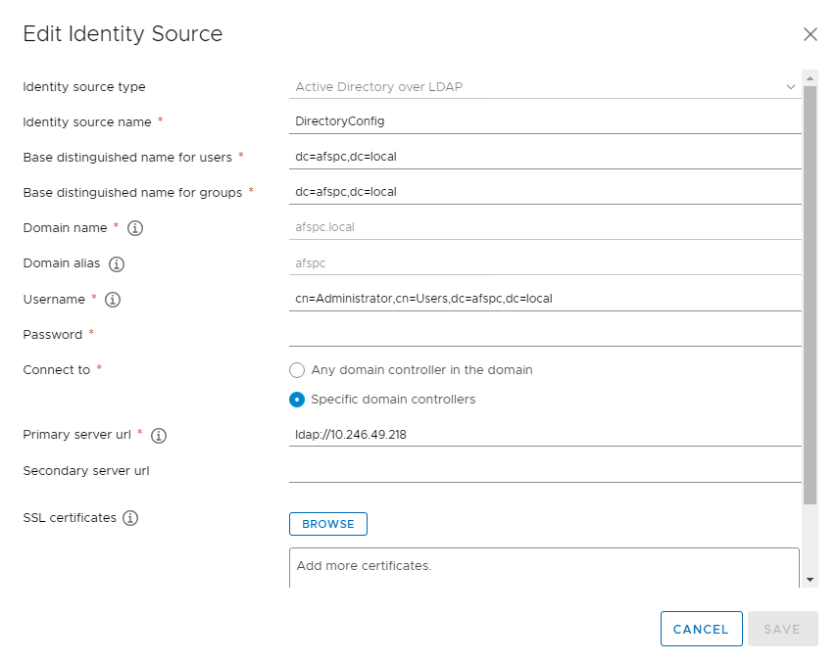

Select “Add Identity Source”

* For Identity Source Type Select “Active Directory over LDAP”
* Provide a Name
* Configure the Base Distinquished Name for Users for example:- dc=afspc,dc=local
* Configure the Base Distinquished Name for Groups for example:- dc=afpsc,dc=local
* Domain Name:- For example afspc.local
* Domain Alias:- afpsc
* Username for example:- cn=Administrator, cn=Users, dc=afspc, dc=local
* LDAP Server: < THEIPADDRESSOFYOURPUAVIPFORLDAP >
* Password: The Password of the User that will connect to the Directory Server
* Under Connect to: ldap://<THEIPADDRESSOFYOURPUAVIPFORLDAP>
  + According to the ESX documentation if you do not specify a port then it will default to 389.
* If using ldaps this will be ldap://< THEIPADDRESSOFYOURPUAVIPFORLDAP >:636
* Also if using ldaps certificates may need to be uploaded
* Select the “Add Button” if there is a configuration issue then the “Add will fail”

Under Users and Groups

Select Your Domain for example “afpsc.local”

You should then be able to see Active Directory Users and Groups Populated in the User Interface.

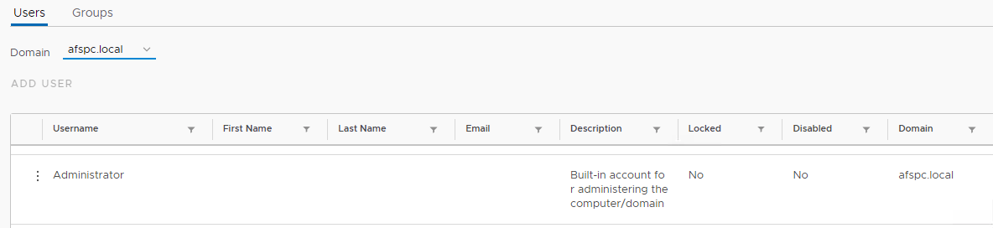

.

Logout of theESXI Server.. and then Log Back in with an Active Directory User to verify that you can login to the system with an AD User directly the Unity User Interface (no Big-IP)

**Note: The DN that username translates to must be in the ephemeral_LDAP_Bypass data-group. Otherwise the PUA system will intercept the authentication and generate an ephemeral credential and the authentication will fail. This data group is under iRules/DataGroup List**

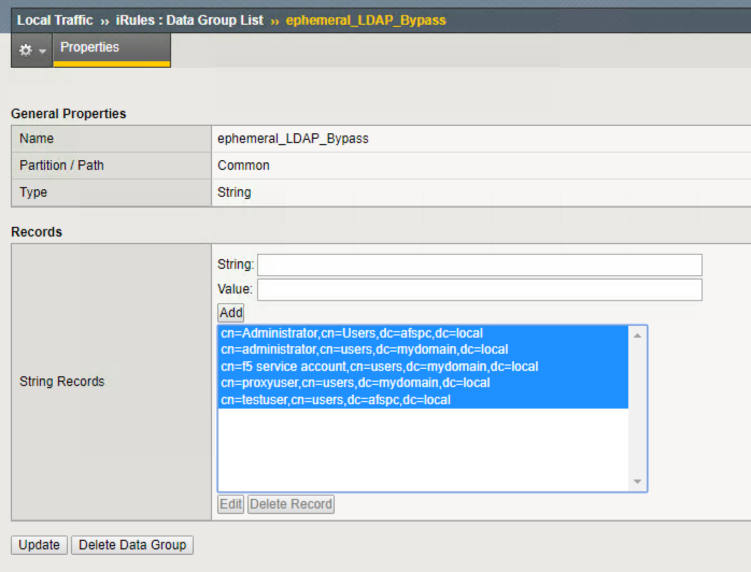

​

1. Create Access Policy for ESXI

Under Access/ “Profiles/Policies”/Access Profiles (Per Session Policies) click “create”.

Provide a name for your access Policy for example:- “ESXI”

For Profile Type Select:- LTM+APM

For Profile Scope Select:- Global

Under Accepted Languages Select:- English

Select Finished.

Under Per Session Policy Select “Edit”

Change the ending to “Allow”.. by clicking on the “Deny” ending and then select the radio button for “Allow”

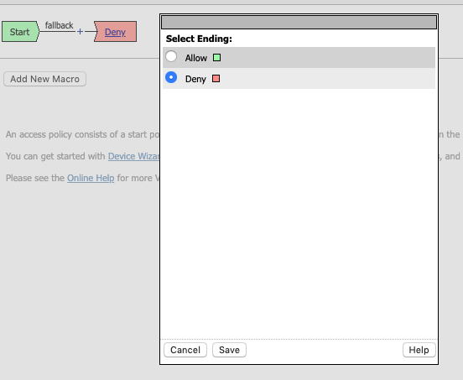

Associate the SSO/Auth Domain with the Access Policy

* Under Access/Profiles/Policies click on the Access Profile Name ..for instance click on “ESXI” if your access profile is called ESXI.
* The properties will be displayed..
* At the top click on the SSO/Auth Domains TAB.

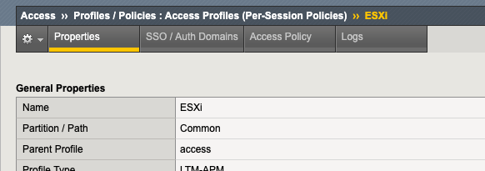

* For Domain Mode select “Multiple Domains:
* For primary Authentication URI.. this will be the FQDN for your PUA webtop for instance : <https://pua.lab.com>
* Under Authentication Domains Select : “Add”
* Then under “Cookie” select “Host”
* For DNS name select the FQDN of the ESXi VIP.
* Make the Cookie “Secure”
* For SSO Configuration select “None”

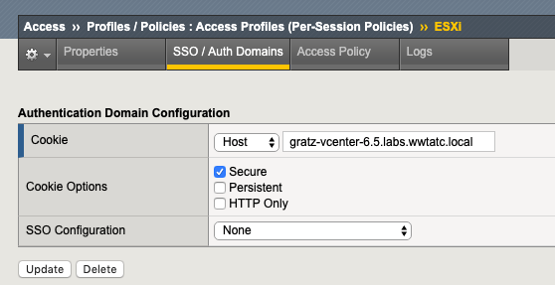

1. Create an HTML content profile rule

This profile will be used in conjunction with the iRule for SSO for ESXI.

Under Local Traffic/Profiles/Content/HTML/Rules

Select “Create New”

Provide a name:- “Script”

Under “Match Settings” for Match Tag Name type:- body

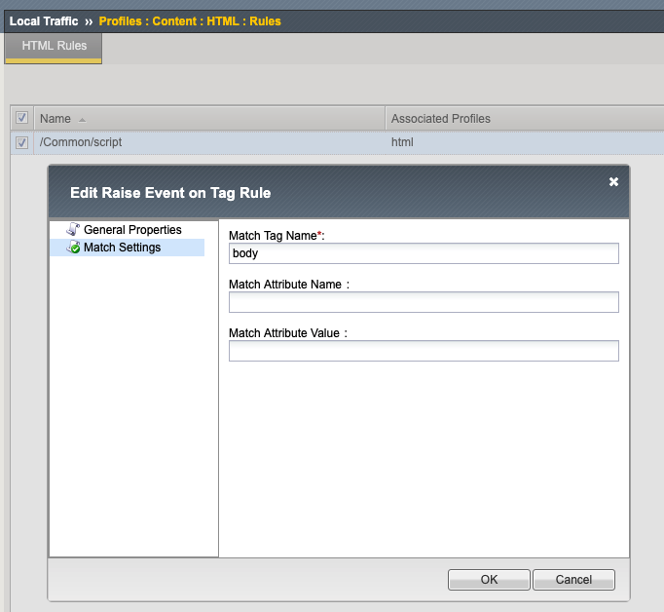

Under.Local Traffic/Profiles/Content/HTML

Select Create Profile

Provide a Profile Name

Under Cotent Settings… add a “Content Type Selection” of

“text/html” and

“text/xhtml”

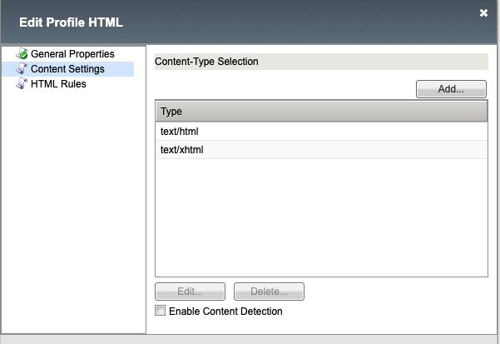

Under html rules associate the “script” rule that was created above.

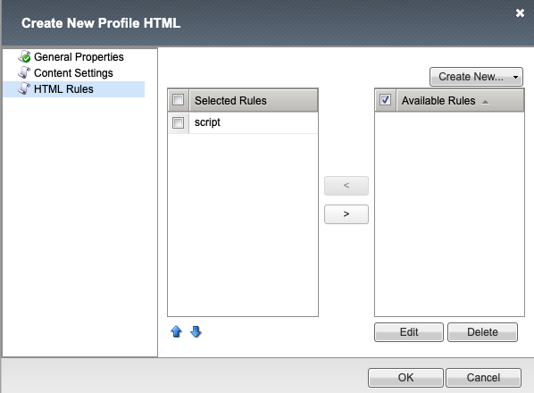

1. Create a pool for ESXi.

N.B. The pool will be associated with the virtual server for ESXI

Under Local Traffic/Pools/Pool List click “Create”

Provide a Name for the Pool

Select a monitor.

Add the ESXi front end ip as a node to the pool member – make the service port 443 for SSL/TLS.

Click “Finished”

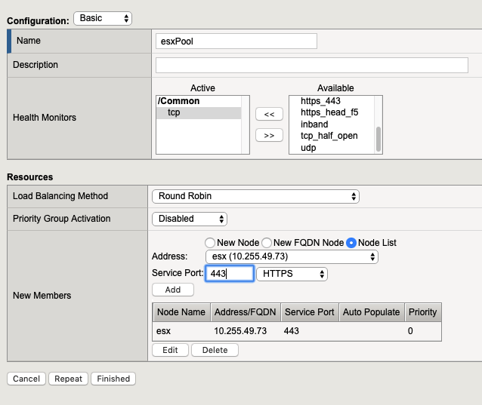

N.B. At this point check that the pool is marked “Available.. “ .. a green circle this will be an indication that the monitor is succeeding and able to make a connection.. the connection type will depend upon the monitor selected.

1. Add the ESXi iRule.

Note: There are a couple of places that require customization with this iRule.

1. Domain for the username.. note that the Active Directory Domain has been appended. Note that with ESXi if you do not set your particular domain as the “Default domain” then the user must append their domain at then end of their user name. For example [bob.user@afspc.local](mailto:bob.user@afspc.local). Just also note that users will be logging in most likely with smartcards but this is an internal configuration change that will be customized depending upon your particular domain.

*set username [concat [ACCESS::session data get session.logon.last.username]@afspc.local]*

1. Redirect in when HTTP_RESPONSE{} event. This will need to be customized for your particular domain. Also the iRule could be modified to add a number of retries in order to limit the possibility of an infinite loop.

# Needs an HTML profile and an HTML rule looking for tag "body"

#

# ltm profile html html { app-service none content-selection { text/html text/xhtml } rules { script } }

# ltm html-rule tag-raise-event script { match { tag-name body } }

# ltm virtual iDRAC-ext { destination 172.16.1.12:https ip-protocol tcp mask 255.255.255.255 pool iDrac profiles { DRAC { } html { } http { } pua_webtop-clientssl { context clientside } rba { } serverssl { context serverside } tcp { } websso { } } rules { iDracRule } source 0.0.0.0/0 source-address-translation { type automap } translate-address enabled translate-port enabled vs-index 13 }

when HTTP_REQUEST {

HTML::disable

if { [HTTP::uri] contains "/websso/SAML2/SSO/vsphere.local" } {

HTML::enable

log local0. "HIT LOGIN"

set workaround 1

} elseif { [info exists workaround] } {

unset workaround

}

}

when HTML_TAG_MATCHED {

log local0. "at HTML_TAG_MATCHED: [HTML::tag name]"

if { [info exists workaround] } {

switch [HTML::tag name] {

"body" {

log local0. "at body..."

set username [concat [ACCESS::session data get session.logon.last.username]@afspc.local]

set password [ACCESS::session data get session.custom.ephemeral.last.password_sso]

log local0. $username

set newstring "<script>

var checkExist = setInterval(function() {

if (document.body.contains(document.getElementById(\"username\"))) {

clearInterval(checkExist);

var un = document.getElementById(\"username\")

un.focus();

un.value = \"$username\";

var ev = document.createEvent('Event');

ev.initEvent('input', true, false);

un.dispatchEvent(ev);

var pw = document.getElementById(\"password\")

pw.focus();

pw.value = \"$password\";

var ev = document.createEvent('Event');

ev.initEvent('input', true, false);

un.dispatchEvent(ev);

var lb = document.getElementById(\"submit\");

lb.focus();

lb.click();

}

}, 4000); // check every 1000ms

</script>"

HTML::tag append $newstring

unset workaround

HTML::disable

}

}

}

}

when HTTP_RESPONSE {

if { ([HTTP::status] starts_with "4") || ([HTTP::status] starts_with "5")} {

HTTP::redirect "https://gratz-vcenter-6.5.labs.wwtatc.local/ui/#?extensionId=vsphere.core.folder.relatedDatastoresTab&objectId=urn:vmomi:Folder:group-d1:65a04749-387e-44a3-a2db-0087096a756a&navigator=vsphere.core.viTree.hostsAndClustersView"

}

}

1. Create the ESXi VIP.

Under Local Traffic Manager/Virtual Servers Click “Create”

For Source Address:- Your choice.. for instance 0.0.0.0/0

For Destination Address:- This needs to be an IP address.. on the external VLAN.

Service Port: HTTPS

Protocol: TCP

HTTP Profile: http

SSL Profile Client: This needs to be a client SSL profile that is customized for the FQDN for ESXi.

Server SSL: select the “serverssl” profile

Source Address Tranlsation: “Auto Map”

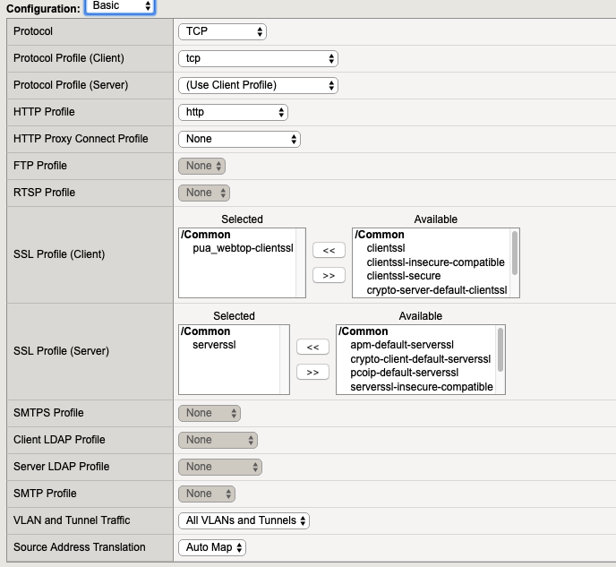

Under Content Rewrite Select “html” (Created Previously)

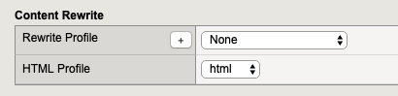]

Under Access Policy Select ESXi or whatever you have named your access policy

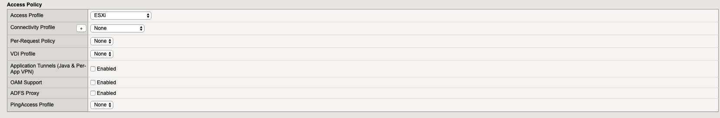

Under Resources

Associate the esxi iRule that was created previously with the VIP

Associate the pool that was created previously wit the VIP

Select “Finished”

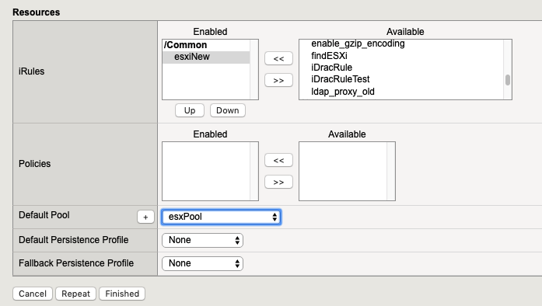

1. Create Portal Access Resource for ESXi

* In the APM menu select Webtops/Webtop Links
  + Click Create
  + Name: Your choice “ESXi” for example
  + Link Type Needs to be Application URI
  + Application URI needs to be the FQDN of the VIP. For example:- <https://gratz-vcenter-6.5.labs.wwtatc.local>
  + For caption: This will be the name that appears on the webtop.

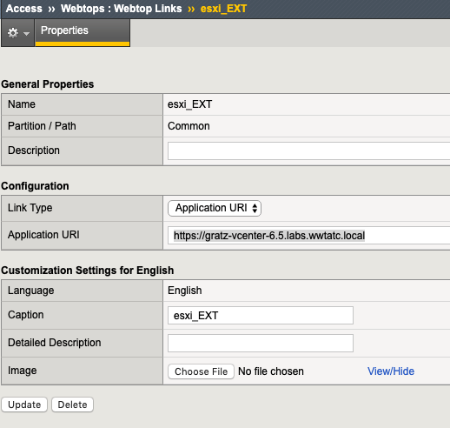

1. You can then associate the ESXi webtop link with the Webtop Policy.

* Click Access/Profiles
* Click “Edit” under Per-Session Policy
* Select the Webtop. This will be associated with an “Advanced Resource Assign Webtop Item”
* Then Select the Add/Delete Button
* Then select the Webtop Links Tab
* Then Select the ESXi webtop link that was created previously.

